Monitor Calibration Tools

Wednesday, July 18, 2018

12:51 PM

**CALIBRATE USING ONLINE TOOLS**

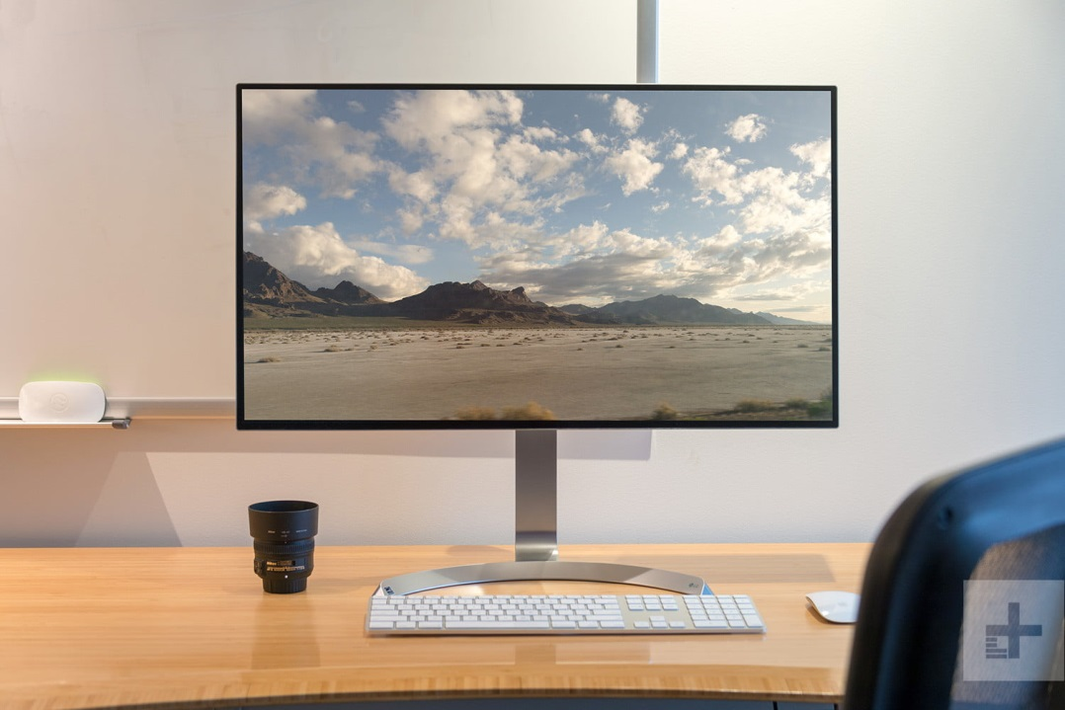

Bill Roberson/Digital Trends

There are a handful of web-based calibration tools that help you manually adjust your monitor settings. They can provide more precise, or more customized, calibration than the built-in utilities.

* + [Photo Friday](http://www.photofriday.com/calibrate.php) — Photo Friday is a simple web page that is designed to help you calibrate the brightness and contrast of your screen. Just adjust the monitor settings until the transition of tones from black to white is clearly distinguishable on the screen.
  + [Online Monitor Test](http://tft.vanity.dk/monitorTest_scale.html) — Online Monitor Test is one of the better calibration websites out there. It is lined with a slew of interactive tests to help you adjust your monitor’s screen colors and to see if your monitor can produce smooth gradients. There are also tools for pinpointing damaged pixels and backlight bleeding, rendering the website one of the more robust web-based calibration tools to date. For more options, move your mouse to the top of the screen where a pop-in menu will appear.
  + [The Lagom LCD Monitor Test Pages](http://www.lagom.nl/lcd-test/) — Handy for both online and offline use, the Lagom LCD Monitor Test Pages not only allow you to adjust various things such as contrast and response time, but allow you to download the images as a 120KB zip file, so you can check any monitor in-store that you are thinking about purchasing.

CALIBRATE USING COLORIMETER HARDWARE

The built-in calibration utilities and web-based software are great for a quick fix, but they are inherently flawed because of one thing — you. These calibration processes rely on an individual’s perception of color and are therefore open to subjectivity based on how you see different colors.

Purchasing a calibrating device is one way to bypass this dilemma and better ensure your monitor is calibrated to its true potential. You will need to invest some serious money if you’re looking for greater precision and control, but there are still some affordable alternatives that work well on a tight budget and will help obtain color consistency across all your monitors.

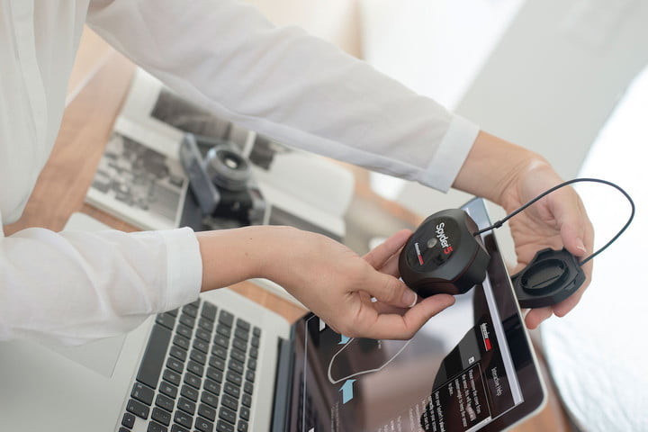

If you’re looking to pick up a calibration tool, we recommend using the [Spyder5Express ($130)](https://www.digitaltrends.com/go/?provider=manual&url=https%3A%2F%2Fwww.amazon.com%2FDatacolor-S5X100-Spyder5EXPRESS%2Fdp%2FB00UBSL2TO%2Fref%3Das_li_ss_tl%3Fie%3DUTF8%26linkCode%3Dsl1%26tag%3Ddigitren08-in-cont-20%26linkId%3Dd4a4198d93baba9d8993e3002ec71b7f%26ascsubtag%3Dcomputing%3A405965), the [Spyder5Pro ($190)](https://www.bhphotovideo.com/c/product/1130968-REG/datacolor_s5p100_spyder5pro_downloadable_software.html), or the [Spyder5Elite ($280)](https://www.digitaltrends.com/go/?provider=manual&url=https%3A%2F%2Fwww.amazon.com%2FDatacolor-S5EL100-Spyder5ELITE%2Fdp%2FB00UBSL3L6%2Fref%3Das_li_ss_tl%3Fie%3DUTF8%26linkCode%3Dsl1%26tag%3Ddigitren08-in-cont-20%26linkId%3D8d0dabec68d7111282c08403ca992ffe%26ascsubtag%3Dcomputing%3A405965). All three devices feature a full-spectrum, seven-color sensor to help accurately characterize a variety of wide-gamut and normal displays, but the more expensive versions are better equipped for the seasoned calibrator and are packed with more features. If you do decide to purchase one, all you have to do is attach the device to the screen, connect it to a USB port, and run the included calibration software. It will walk you through the process after that.

X-Rite’s [ColorMunki series](http://www.colormunki.com/) ($100 and up) is also a good alternative. Like the Spyder series, all three devices come bundled with automated calibration software, with the more expensive versions touting more features and greater customization.

Pasted from <<https://www.digitaltrends.com/computing/how-to-calibrate-your-monitor/>>